Institute of management Sciences
Discrete Structure BS (CS) Hons 3rd Semester
Mid Term Examination (Fall Semester) Total Marks: 30 Max Time: 1:30 Hour
Q1: Simplify the following Statement using laws of logic. (12 Marks)
- $(P∧Q)∨(\left(¬P∧Q\right)∧\left(P∧¬Q\right))$
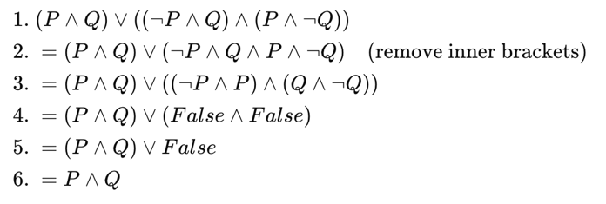

- $\left(P∨Q\right)∧(P∨¬Q)$
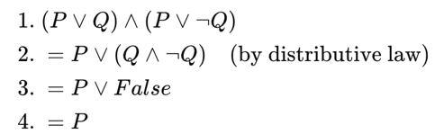

- $(¬P∨Q)∧(P∨Q)$
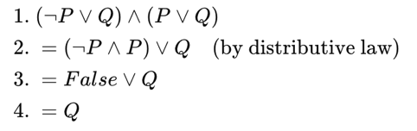

- $(P∨Q)∧(¬P∨Q)∧(P∨¬Q)$
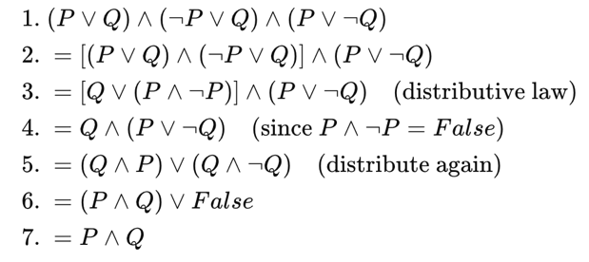

Q2: Create Statement from the following Logic Circuit. (3 Marks)
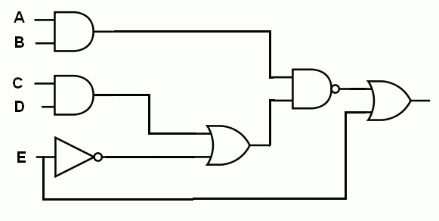
¬((A∧B)∧((C∧D)∨¬E))∨E
(A∧B)∧((C∧D)∨¬E)∨E (I will accept that as well as we didn’t cover NAND)

Q3: Create Logic Circuit from the following statements. (4 Marks)
- $(P∧Q)∧(¬P∨¬Q)∧(¬P∨¬Q)$
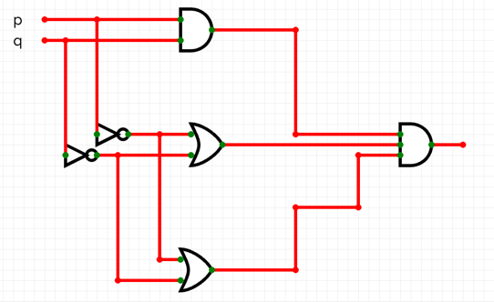

- $(¬P∨Q∨R)∧(P∨¬Q∨R)∧(P∨Q∨¬R)$
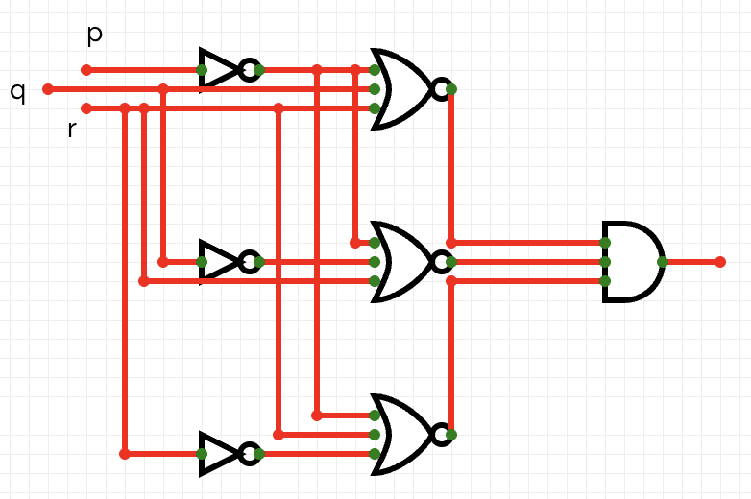

Q4: Prove that $¬p∧¬q≡¬(p∧q)$ or not (using Truth Table). (4 Marks)
p | q | ¬p | ¬q | ¬p ∧ ¬q | p ∧ q | ¬(p ∧ q)
0 | 0 | 1 | 1 | 1 | 0 | 1
0 | 1 | 1 | 0 | 0 | 0 | 1
1 | 0 | 0 | 1 | 0 | 0 | 1
1 | 1 | 0 | 0 | 0 | 1 | 0

Q5: Let $U=\{1,2,3,4,5,6,7,8,9\}$, $A=\{1,2,3,4,5\}$, $B=\{3,4,5,6,7\}$ Find: (4 Marks)
- $A\text{'}$
$$A^{'}=\{6,7,8,9\}$$
- $B\text{'}$
B′={1,2,8,9}
- $A\text{'}∩B$
A′∩B={6,7}

- $(A∪B)\text{'}$
(A∪B)′=U−(A∪B)={8,9}

Q6: Write the set expression that represents the shaded area in the Venn diagram (3 Marks)
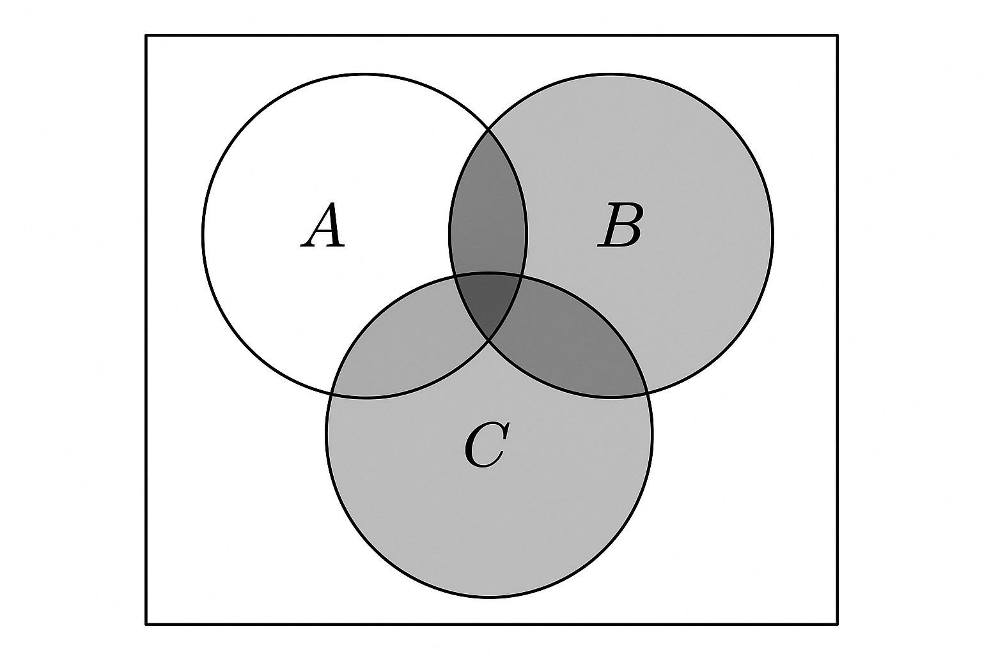

B∪C

